**Pre-requisite -** Visual Studio Professional 2019

**Design Details**

**UI Controllers**

1. Add the group box control; caption the name to “Volume in dB”.
2. Add the slider controller, set the minimum and maximum value to 0 and 80 respectively, and set the fore ground color to blue.
3. Add the 9 text block controllers, caption name to “0” to “80” respectively.
4. Add the check box controller, caption name to “Modify Volume”. Set the check box status to enable by default.
5. Add the text box controller; slider value in dB is displayed in the text box.

When the “Simple Volume Controller” app launched, “Modify Volume” check box is enabled, if this check box status is enabled Slider controller and text box controller allowed to modify, else, Slider and text controllers disabled. Text box controller initial focus set when app launched, and value set to 0.

When the slider controller value updated, simultaneously slider value updated in text box controller. Also, if text box value entered between 0 to 80 entered, simultaneously slider controller value also updated. If the entered value not in the range 0-80, a pop-up “The value should not be more than 80.” displayed.

Defined the wrapper class “SliderData” to save the slider value.

**Use Cases**

1. Simple Volume controller App launched, the “Modify Volume” check box enabled by default. Initial focus set to the text box and setting value to 0.

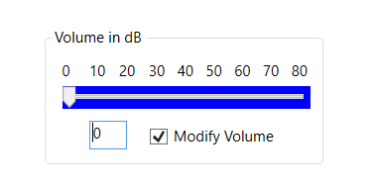

1. Update the slider position, the slider value updated on the text box controller.

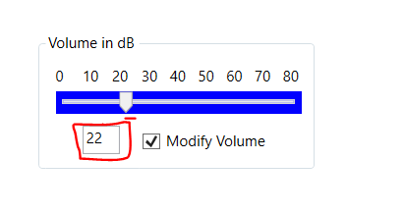

1. Update the slider position from the text box.

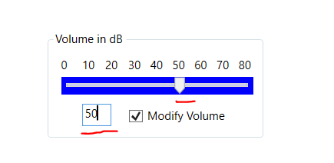

1. If the entered value more than 80, a pop-up displayed.

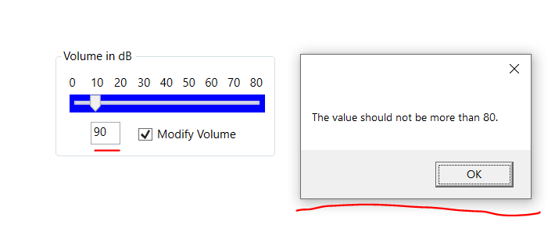

1. Setting the text box value to empty or 0, slider position set to 0.

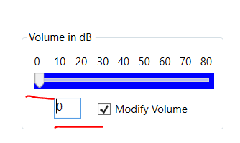

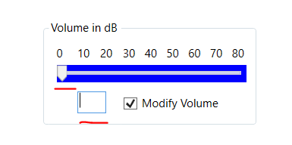

1. Slider and text box controllers disabled if the “Modify Volume” check box is disabled.

